Introduction
Buttons for manually controlling the outputs and LEDs for indicating output status are needed. Buttons will be connected to the MCU and LED-s are controlled by the MCU. RGB LED-s with serial data interface is used to reduce the number of MCU pins needed.

LED-s
IN-PI22TAT5R5G5B will be used and typical application schematic followed.

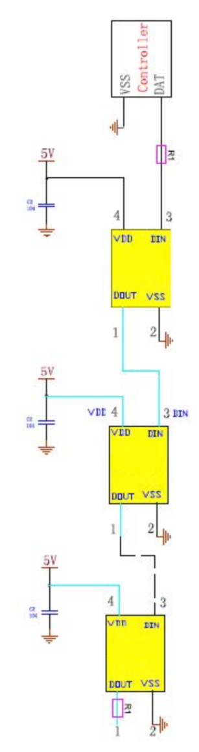
Figure 1: Typical Application Circuit

The LED operates from 5V supply, but MCU is using 3.3V. A level translator shall be used.
A common N-FET based translation circuit is used. In series diode will be used on the data line to prevent current flowing from 3,3V supply to LED supply.
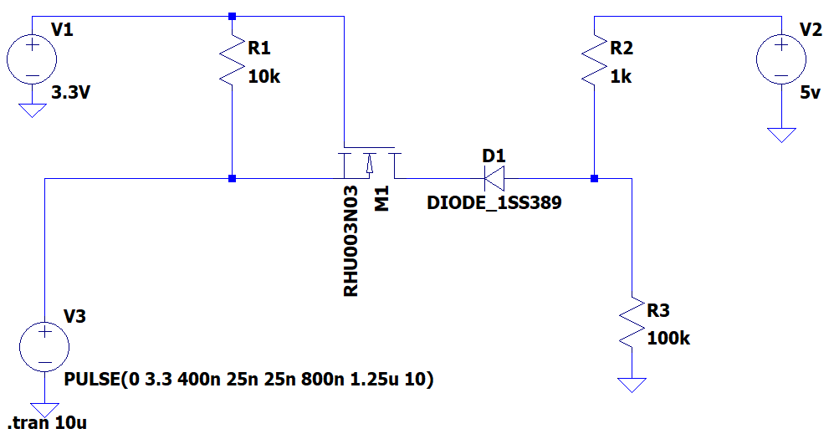
Figure 2: Level Shifter for LED data
R3 simulates the load presented by the LED DIN pin. In reality the load is probably smaller.
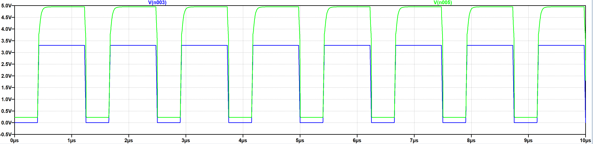
Figure 3: Level shifter simulation results.

Typical application circuit requests a series resistor on the DATA line. The exact quote is: “Product signal input and output must be connected in series with protection resistor R1. R1 depends on the size of the cascade amount, the greater the number of cascades, the smaller R1. The general recommended value is between 200-2KΩ, usually the recommended value is typical 500Ω.”.

The wording seems to apply, that the intended product is a stand-alone LED strip. In that case the resistors are justified since users have access to those pins. In case of this project those are not needed.
Instead a place for termination resistor is reserved after the last diode in the chain.
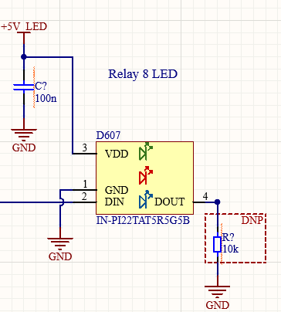
Figure 4: Last LED in the chain

LED supply will be switchable to avoid stability issues.
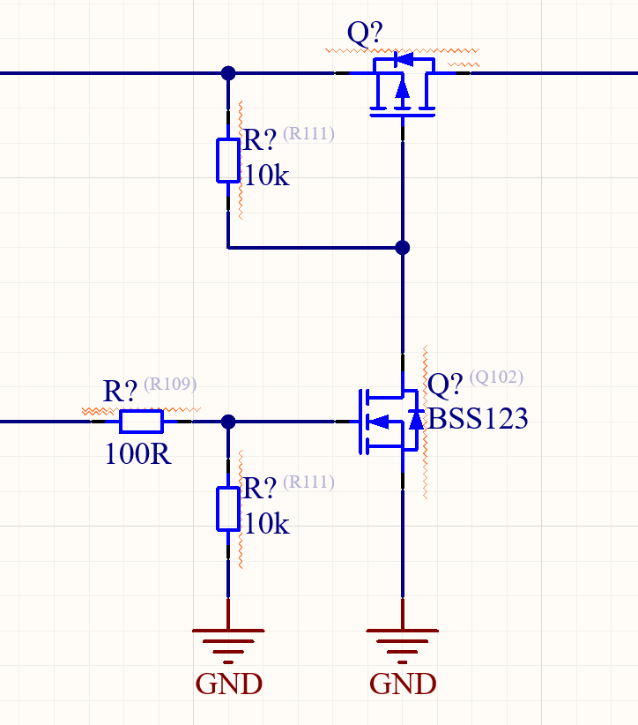
Figure 5: LED power switch
Each LED has a light guide.
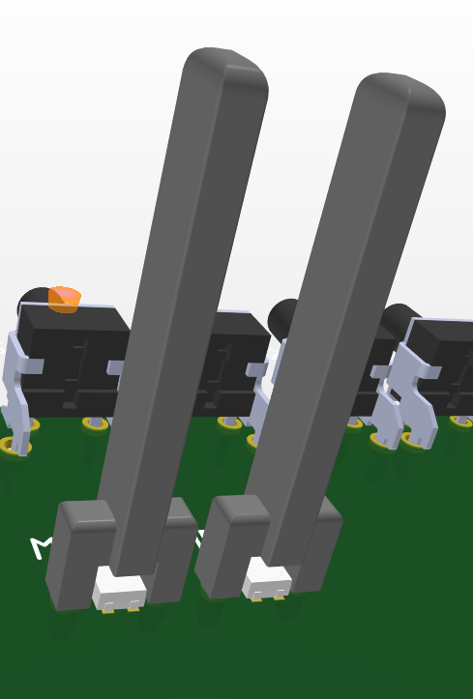
Figure 6: Light guides

Buttons
The button circuit is as shown below.
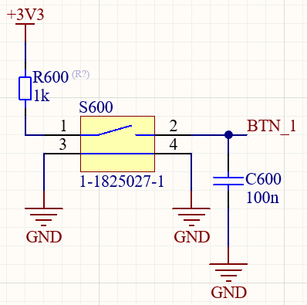
Figure 7: Button circuit
Components from other circuits were used. Time constant for the RC circuit is 0,1 ms. The resistor is placed before the switch so if there is a short circuit to ground inside a switch (which is unlikely) the entire +3V3 is not shorted. 1kΩ resistor is selected since the internal pull-down of the MCU pin is the range of 30kΩ to 50kΩ. Internal pull-down is needed to drain the capacitor once button is released.

